Assignment 11.2:

Write the Pig codes to analyze the Student data set.

1. Find the number of students who scored less than 5(50%).

Pig Script:

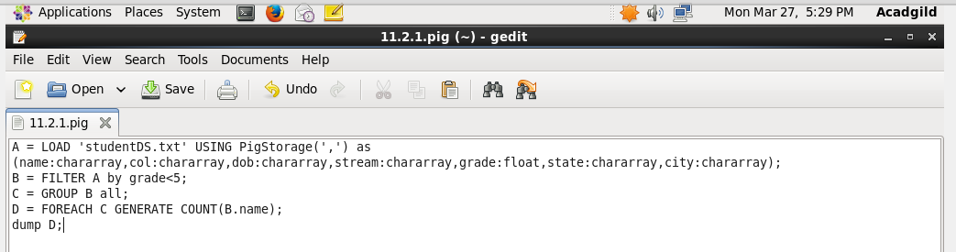

Executing the pig script:

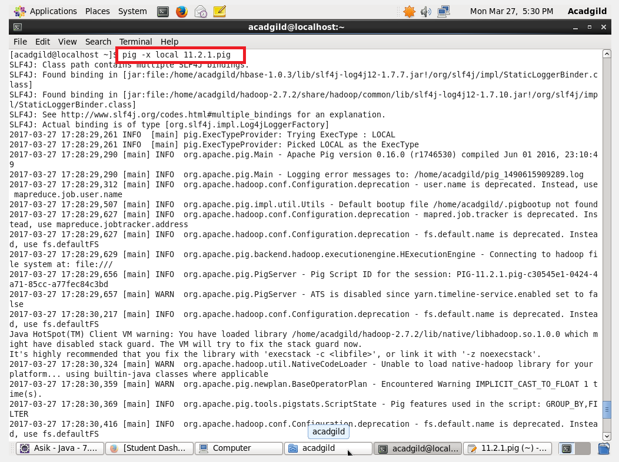

Output:

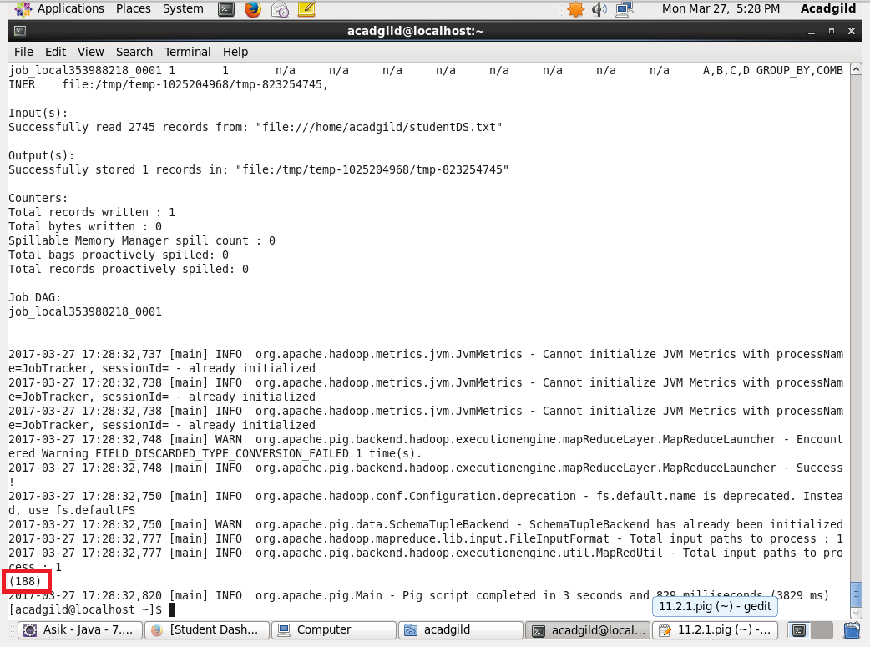

2. List the name of students who are from Alaska.

Pig Script:

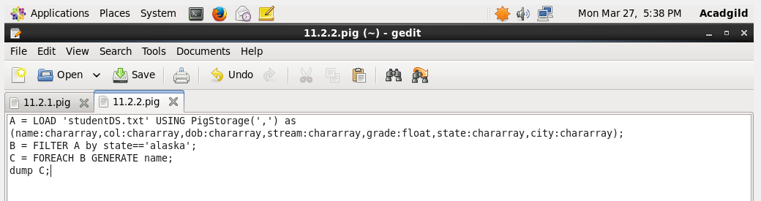

Executing the Pig script:

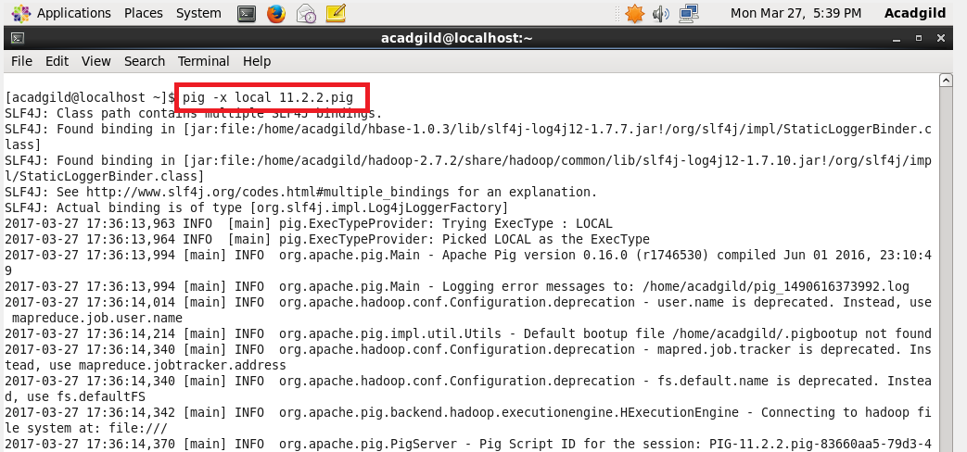

Output:

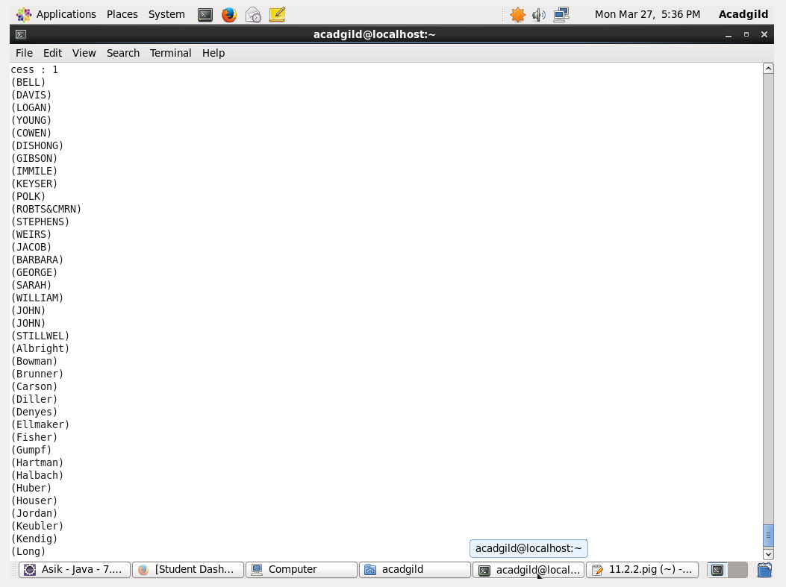

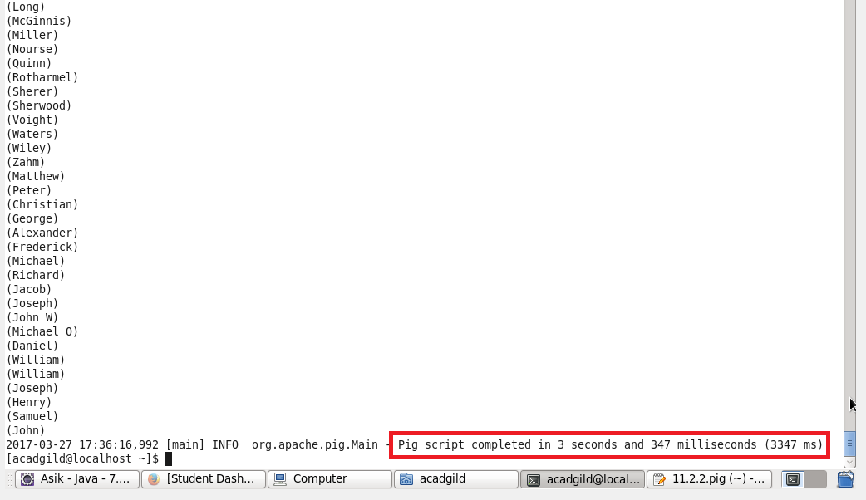

3. How many government colleges are there in Alabama?

Pig Script:

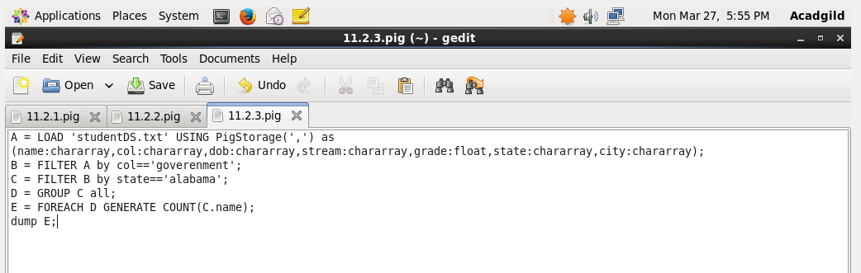

Executing the pig script:

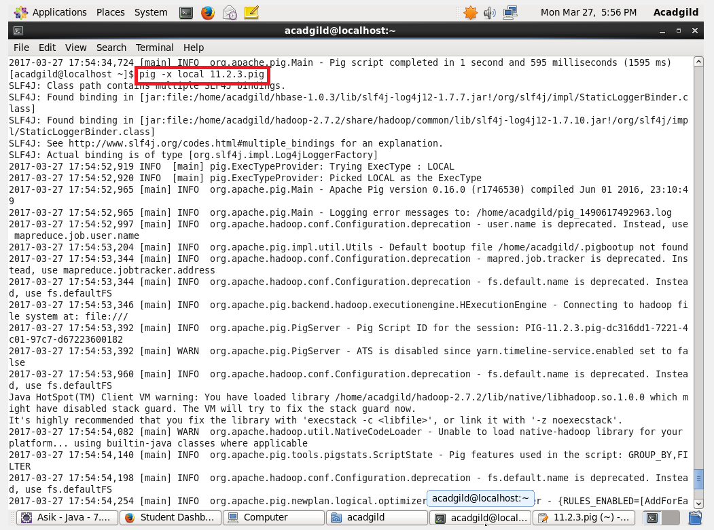

Output:

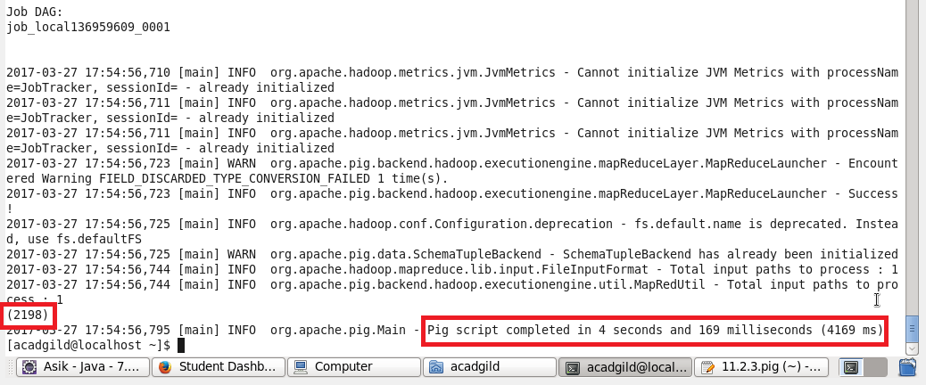

4. List the name of students who are from Oregon and persuing BE.

Pig Script:

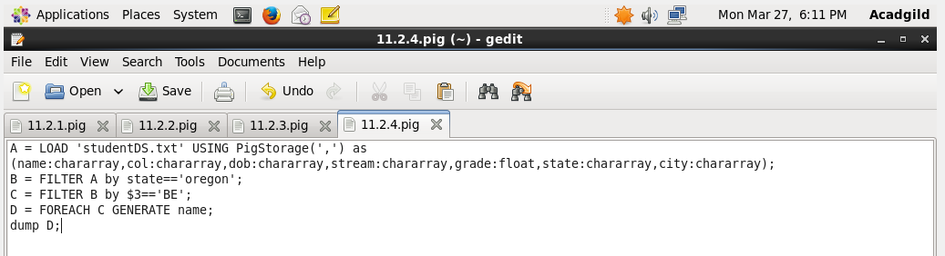

Executing Pig Script:

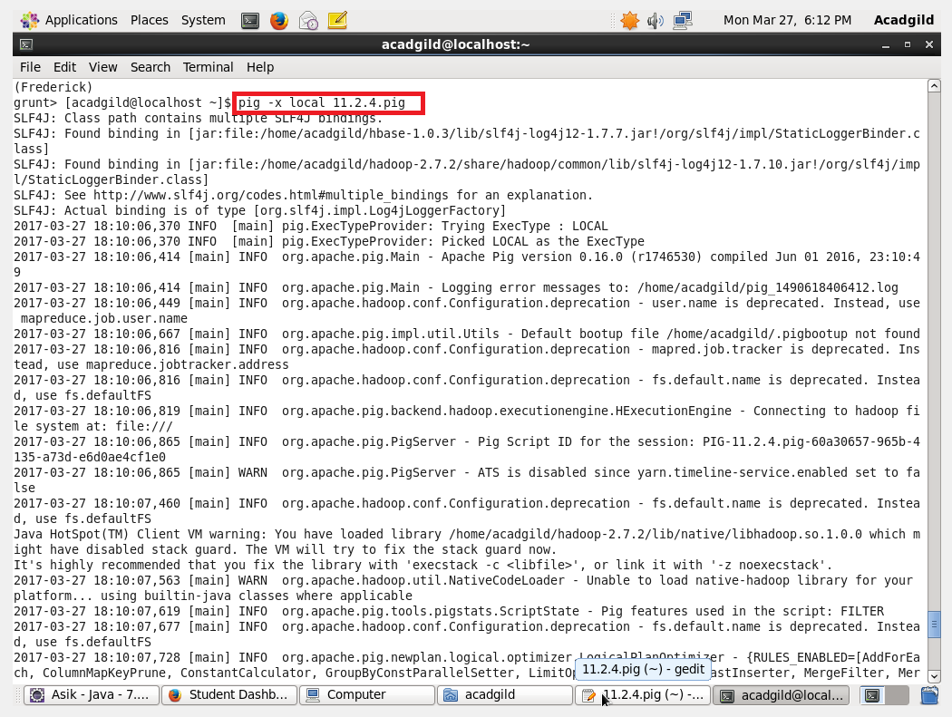

Output:

